- Coral Shine 
- Audacious Coral 
- Candy Shine 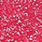
- Nude Shine 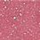
- Sweet Shine 
- Sun Shine 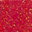
- Amorous Pink 
- Charming Pink 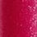
- Red Shine 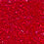
- Auburn Shine 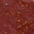
- Toffee Shine 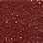
- Rose Shine 