2 – Shimmering Beige
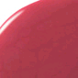4 – Rouge

7 – Pale Shimmering Rose
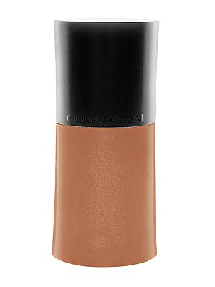3-Golden Bronze
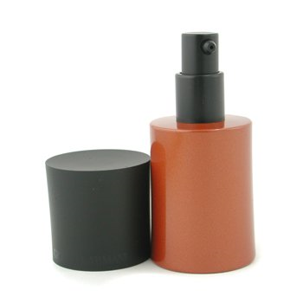8-Sienna

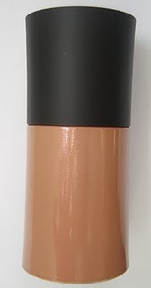10 Golden Beige
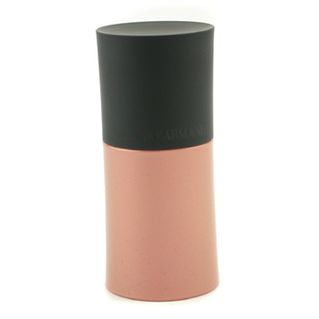11 Amber

