

15 Orchid Rose



63 Plum Atraction



64 Pink Explosion



65 Espiegle



68 Rose Ecrin



72 Rose Initiale



82 Reflex



99 Rose Petal
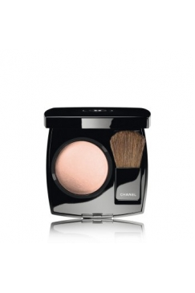Star Dust Christmas /limitovaná edícia/

