Soft and Gentle
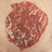 Precious Pearl
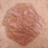Crystal Pink
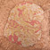Goldstone
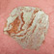Rose Quartz
Gold Deposit

