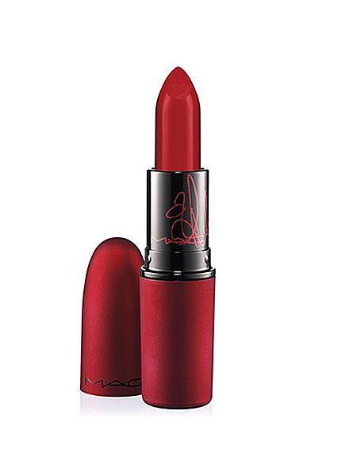

M·A·C Viva Glam Rihanna Lipstick
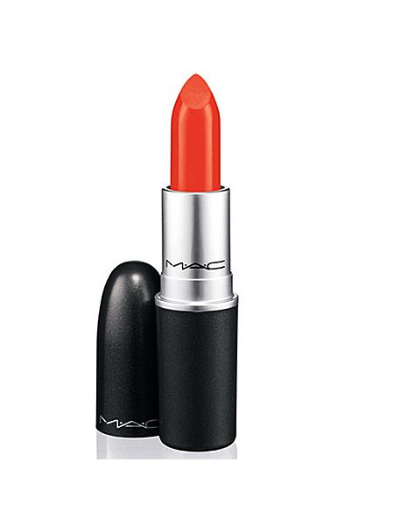
Morange
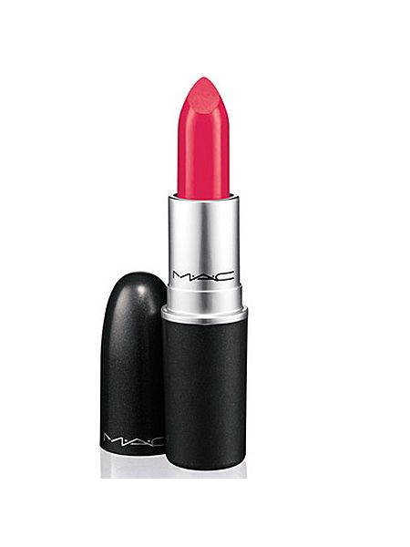
Impassioned
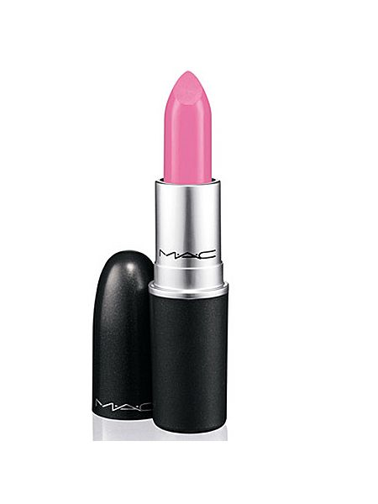
Saint Germain
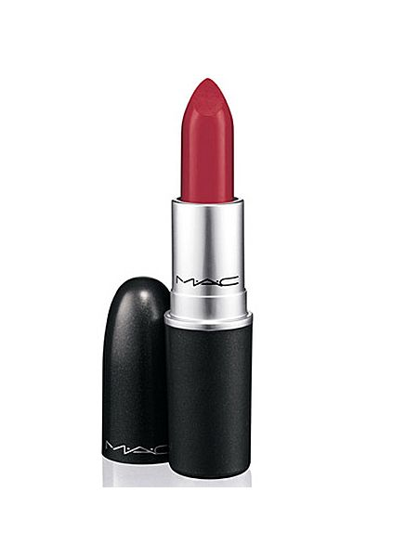Russian Red
- Japanese Maple
- Sunny Seoul
- Peach Blossom
- Pure Zen
- Pink Pearl Pop
- Shanghai Spice
- Saion Summer

