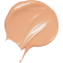 | 102.5 - Porcelain
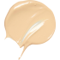 | 103 - Ivory
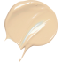 | 105 - Nude
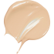 | 107 - Beige
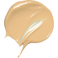 | 108 - Sand
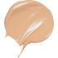 | 109 - Wheat
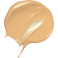 | 110 - Honey
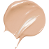 | 112 - Amber
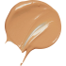 | 113 - Chestnut
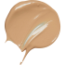 | 114 - Cappuccino

